PROBLEMS ENCOUNTERED
When filling out this template, DELETE all highlighted text before submitting.
Use this template to submit your pre-lab and write-up on Canvas.
For the pre-lab submission, include only the Problems Encountered, Introduction, and Discussion sections, along with your completed work from the lab instructions.
For the write-up submission, expand on your pre-lab by adding your in-lab work. Be sure to revise or correct any parts of the pre-lab as needed to avoid losing points again. In addition, complete the Discussion and Conclusion sections of the document.
The final write-up submission for each lab should be a complete document that includes all your work (prelab + in-lab) for the lab.
As you go through the lab, bullet point any issues you had during the lab, so essentially any parts of the lab you had trouble understanding or getting to work correctly. This is helpful for us in helping you debug your circuits, and for you in fixing any future problems you have when putting the lab modules together for your final project.

INTRODUCTION
In two to four sentences, write a brief but descriptive introduction summarizing the purpose and key concepts of the lab.

DISCUSSION
Guidelines:
- For every value listed, include the appropriate units.
- Include 2-3 significant figures for your values.
- Label and caption all images and tables as shown below.
- The grader should be able to tell that the writer understands the subject material.
- The cleaner everything is organized, the easier it is for your TA to grade.

First Section
Have a description here of what is occurring in this part of the lab. One to two sentences. Do this for each section of the lab.

First Subheading
Use subheadings as necessary.

Expected Voltage (V) | Measured Voltage (V) | % Error
5.00 | 4.87 | 2.6
4.50 | 4.26 | 5.3
Table 1: Node voltages and the percentage error of the circuit. (Table is here as an example. Include units, and titles as needed for each section).

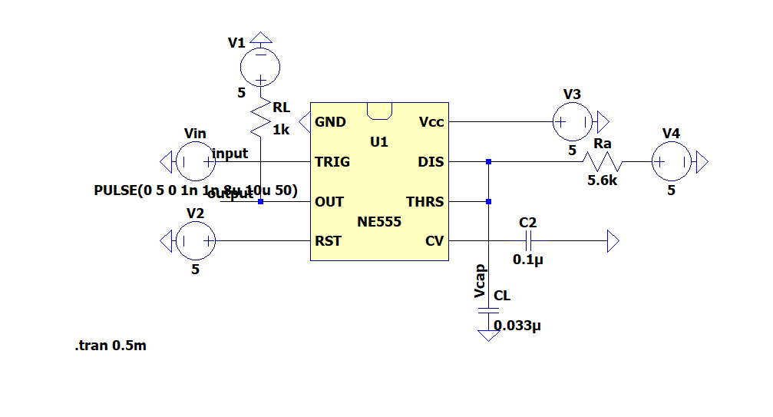
Figure 1: Mono-stable circuit of NE555 Timer. (Example circuit used to demonstrate how to include images in the template. Include a short description of the circuit).

Discussion Question: Each lab will have one to several questions to answer about the in lab. Do this here. No answer to a single question should need to be more than 4 sentences but ensure you right enough to fully prove/ flesh out your answer

CONCLUSION
This should be 2 to 4 sentences, for the write up only explaining overall what you specifically carried out in this lab.

